

# The Sims™ 4

# THE SIMSTM 4: ISLAND LIVING

Browse this pack’s content and get inspired by more fashion, furniture, hairstyles, and décor. Imagine what you’ll make next!

## ***Engage in Local Culture***

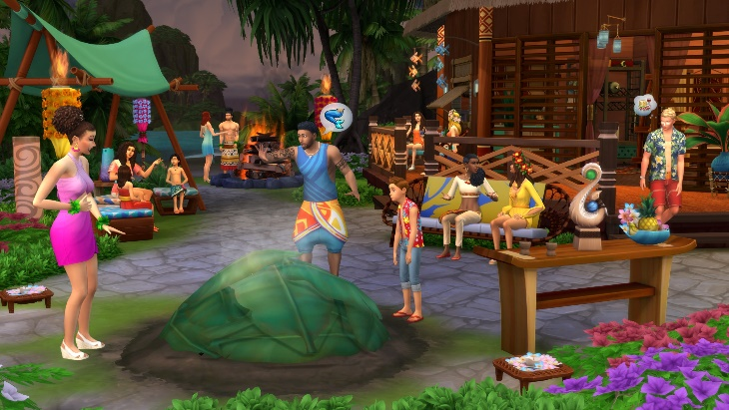

Tradition runs deep on Sulani, and your Sims get to experience everything it has to offer. Immerse Sims in their newfound lifestyle by attending a pit barbecue event, learning about local folklore, tasting tropical delicacies and chatting with ancestors from the island.